**Week 17: December 16-20**

**Do Now:**

1. **Complete the study guide for extra credit if you have not done so**
2. **Study for the Exam using your study guide**
3. **If you are STILL failing, work on missing assignments; there is TIME**
4. **Options after Exam**
   1. **Sleep**
   2. **Read**
   3. **Do work on computer/study for another exam**
5. **NOT OPTIONS**
   1. **Restroom**
   2. **Front office**
   3. **Another teacher**
   4. **Anything not listed**
6. **EXAM instructions**
   1. **Go to joinmyquiz.com**
   2. **Use code:**
   3. **Use your first name and last initial**

**Week 16: December 9-13**

**Do Now: 12/9/24 & 12/10/24**

1. **Review warmup, warmup, and cool down with group members (same as past fours weeks)**
2. **We will do the Pacer Test 12/11/24**
3. **We will do the Push ups & Curl ups for fitness gram 12/12/24**

**Classwork: 12/9/24 & 12/10/24**

1. **Complete warmup, workout, & cooldown with group (3 mins, 6 minutes, 3 minutes)**
2. **Work on Missing assignments & Final Exam Study Guide if you are not exempt**

**Do Now: 12/11/24**

1. **Class Warmup & Pacer Test Expectations**

**Classwork: 12/11/24**

1. **15 minute Pacer test using Cadence (students record data & give to coach)**
   1. **Report to coach once complete**

**Do Now: 12/12/24**

1. **Class wamup**

**Classwork: 12/12/24**

1. **Student work with partner to complete curl ups then pushups**
   1. **Partner keep up with count and record data** 
      1. **Report to coach once complete**

**Do Now: 12/13/24**

1. **Complete missing work & final exam study guide during class time if you are not exempt and/or if you are failing**

**Classwork: students can walk, play, or complete work based on current grade in class**

**Week 15: December 2-6**

**12/6/24**

**Do Now: 12/6/24: Work on Missing Assignments (use the information you gathered the previous day)**

**Classwork: 12/6/24 another MAKEUP DAY**

1. **If you are not exempt, Complete the FINAL EXAM Study guide**
2. **Work on Missing Assignments if you are failing and/or near exemption**

**12/5/24**

**Do Now:**

1. **What grade do you need to exempt this class?**
2. **What is your current grade in this class?**
3. **If you are not exempt, Go to your Infinite Campus and list your three lowest assignments and the grade you earned. Then go to my teacher’s page and find the assignment using the date from Infinite Campus and see if you will be able to complete it by Monday Dec. 9th -write yes or no next to the assignment**

**Classwork: 12/5/24 -MAKEUP DAY: Work on missing assignments and give to Coach Thomas for updated grade**

**Classwork: 12/5/24 Final Exam Study Guide**

**PE Final Exam Study Guide (There are 20 questions)**

This study guide will help you prepare for the final exam by reviewing key concepts, skills, and rules covered during the semester. Complete the questions below and use the provided information to reinforce your understanding.

**Heart Rate and Fitness Principles**

1. **Define the following terms:**
   * Maximum Heart Rate (MHR)
   * Target Heart Rate (THR)
   * Resting Heart Rate (RHR)
2. **Explain how to calculate your Maximum Heart Rate (MHR).**
3. **Why is it important to know your Target Heart Rate (THR) when exercising?**
4. **Describe the FITT principle and how each component (Frequency, Intensity, Time, and Type) relates to creating a workout plan.**

**Volleyball Skills and Rules**

1. **Explain the purpose of a bump in volleyball. When is it used?**
2. **What is a set, and how does it differ from a bump?**
3. **Describe the basic rules of serving in volleyball.**

**Basketball Skills and Rules**

1. **List three fundamental skills in basketball and explain their importance.**
2. **Describe the correct form for shooting a basketball.**
3. **What are the basic rules for dribbling in basketball?**

**CPR/AED Basics**

1. **What does CPR stand for, and when should it be used?**
2. **Explain how to use an AED in an emergency.**
3. **Why is knowing CPR/AED important for safety in physical education?**

**Major Muscles**

1. **Identify the following major muscles in your body:**

* Quadriceps
* Biceps
* Pectorals
* Hamstrings
* Deltoids

1. **Which exercises target the biceps and quadriceps?**

**Safe Workout Practices**

1. **What is the importance of warming up and cooling down before and after exercise?**
2. **Explain why proper hydration is critical during physical activity.**

**Scenarios**

1. **You are playing basketball, and an opponent keeps blocking your passes. What strategy could you use to improve your gameplay?**
2. **During a volleyball match, the ball is served to your team, and it’s coming toward you. Describe the proper technique to receive the ball using a bump.**
3. **You are creating a workout plan using the FITT principle to improve your endurance. Provide an example of how you would structure this plan.**

**Study Tips:**

* Review your notes from class and practice the skills during free time.
* Create flashcards for terms like MHR, THR, and the FITT principle.
* Practice CPR steps and review AED usage from your training materials.
* Revisit basketball and volleyball rules and try scenarios with a partner or small group.
* Familiarize yourself with muscle groups by completing stretches or workouts targeting them.

Prepare well, and good luck on your final exam!

**Design Workout Groups**

1. **Do Now: 12/3/24 & 12/4/24:**

**On the top of your workout page, write your Group letter, number & color (each person in the group should do it in their own notebook): LET ME KNOW ASAP IF YOUR NAME IS NOT ON HERE**

|  |  |  |  |  |  |  |  |  |  |
| --- | --- | --- | --- | --- | --- | --- | --- | --- | --- |
| **Period** | **Group A**  **1**  **Red** | **Group B**  **2**  **Yellow** | **Group C**  **3**  **Blue** | **Group D 4**  **Orange** | **Group E 5**  **Green** | **Group F 6**  **Purple** | **Group G**  **7**  **Blue 2** | **Group H**  **8**  **Red 2** |  |
| **1** | Jonathan  Nathan | Kamryn  Lakelin  Jasmine | Kovais  Christian  Deantre  Javares | Jordan  Cassie  Deliford  Kiamora | Hopper  Alexis  Aleya  Miranda |  |  |  |  |
| **2** | Jaxon  Jermaine | President  Necey  Jazlyn  J’Mycal | Christopher  Evan  Niya |  |  |  |  |  |  |
| **3** |  |  |  |  |  |  |  |  |  |
| **4** | Danielle  Camiona  Maliyah  Skylen (Ian)  Tiana | Darius  Jayden  Jalee  Lyric | Bryce  Elijah  Christen  Christian  Aleia | Keilan  Malikah  Foster | Kiara  JaKiah  Jayla | Cassidy  Janiya | Louis  Chance  Michael | Kimani  Haile  Datriuana  KJ |  |
| **6** | Foster  McCleod  Malakai  Armani | Merriweather  John  Chase  D’Nya  Tristan  Bryant |  |  |  |  |  |  |  |
| **7** |  |  |  |  |  |  |  |  |  |

12/3/24 & 12/4/24: Thing I am checking for: but not limited to (50 points each day)

1. You are with your group in designated area
2. You have your notebook opened to the workout with your group number, color, and letter
3. Complete warmup properly with effort
4. Complete workout properly with effort
5. Complete cool down properly with effort
6. Group if confident and knowledgeable of exercises being performed and did not have to ask questions

**December 2, 2024**

**Do Now: Write the Success Criteria (on board & below) for this unit**

1. **I can design and implement my own fitness plan using my SMART goal and the FITT standards**
2. **I can demonstrate the proper technique for performing exercises.**

**Classwork: December 2, 2024**

1. **Video (3 takeaways)**
   1. [**https://www.youtube.com/watch?v=F_Q4GcNN2dE**](https://www.youtube.com/watch?v=F_Q4GcNN2dE)
2. **Review examples of correctly done workout plans**
3. **Students work with group member to modify and complete check sheet for workout plan**

|  |  |  |  |
| --- | --- | --- | --- |
| **Group Members:** | | | |
| **Component** | **Criteria** | **Yes/No** | **comments** |
| **Warmups** | **Static & dynamic exercises identified and listed** |  |  |
| **Warmup** | **Amount of time along with total time listed & 3-5 minutes in length** |  |  |
| **Workout** | **At least 4 anerobic exercises listed and identified with amount of sets and reps/time included for each** |  |  |
| **Workout** | **At least 4 aerobic exercises listed and identified with amount of sets and reps/time included for each** |  |  |
| **Workout** | **Exercises do not require equipment & Include both upper and lower body exercises and they are identified** |  |  |
| **Workout** | **Used 2 set of 15 reps, 3 set of 10 reps, 2 sets of 30 seconds or 2 sets of 15 seconds and no more than 15 minutes total for time** |  |  |
| **Cool down** | **There are 2 phases in the cool down for a time of about 2-3 minutes in length** |  |  |

1. **Students given time to work on missing assignments from November 18-22**

**Week 14: November 18-22**

**November 18**

**Do Now: 11/18**

1. **List your four group members from this class (this would include you and three others)**

**Classwork: 11/18**

1. **Using the study sheet, answer Part A Questions with the heading: Workout & Exercise Study Sheet**
2. **Begin determining the exercises you want to perform using the link from coach if needed**

**Workout and Exercise Study Sheet**

**1. List Three Components of a Workout**

1. **Warm-Up**: Prepares the body for exercise by gradually increasing heart rate and circulation.
2. **Main Workout**: The primary activity focused on achieving fitness goals (e.g., strength training, cardio).
3. **Cool-Down**: Helps the body transition back to a resting state, reducing soreness and stiffness.

**2. List the Two Types of Warm-Ups, Including Examples of Each**

1. **Dynamic Warm-Up**: Involves active movements to increase heart rate and flexibility.
   * Examples: Arm circles, high knees, walking lunges.
2. **Static Warm-Up**: Focuses on holding stretches to loosen muscles.
   * Examples: Hamstring stretches, calf stretches, quad stretches.

**3. List Three Benefits of Warming Up Prior to a Workout**

1. Reduces the risk of injury by preparing muscles and joints.
2. Enhances performance by increasing blood flow and oxygen delivery to muscles.
3. Improves flexibility and range of motion.

**4. What Is a Good Time Range for a Warm-Up?**

* A warm-up should typically last **5–10 minutes**, depending on the intensity of the workout.

**5. How Is FITT Used to Determine One’s Workout Plan?**

The **FITT Principle** helps individuals create an effective and personalized workout plan by focusing on four key components: **Frequency, Intensity, Time, and Type**.

**6. List Every Letter of FITT and the Word That Corresponds with a Brief Explanation**

1. **F - Frequency**: How often you exercise (e.g., 3-5 times per week).
2. **I - Intensity**: How hard you exercise (e.g., moderate vs. vigorous effort).
3. **T - Time**: How long you exercise per session (e.g., 30-60 minutes).
4. **T - Type**: The kind of exercise you do (e.g., cardio, strength training).

**7. List Two Phases of a Cool-Down**

1. **Active Recovery**: Gradually decreasing activity to bring heart rate down.
   * Examples: Slow jogging, walking.
2. **Stretching**: Holding stretches to relax muscles and improve flexibility.
   * Examples: Forward fold, seated hamstring stretch.

**8. Explain the Difference Between Anaerobic and Aerobic Exercise**

1. **Anaerobic Exercise**:
   * Short bursts of high-intensity activity without reliance on oxygen.
   * Examples: Sprinting, weightlifting.
   * Focus: Builds strength and power.
2. **Aerobic Exercise**:
   * Sustained, moderate-intensity activity that uses oxygen for energy.
   * Examples: Running, swimming, cycling.
   * Focus: Improves cardiovascular endurance.

**Part A: Answer the following questions: write the questions & answer or restate question in answer DUE: November 18**

1. List the 3 components of a workout. (use workbook information)

_____________________________ ________________________ _____________________

1. List 2 types of warmups and an example of each (specific exercises)

_____________________________________ ___________________________________

1. List 3 benefits of warming up prior to exercise
2. ________________________________________________________________________
3. ________________________________________________________________________
4. ________________________________________________________________________
5. What is a good time range for a warmup? (include the units)

_________________________________________________________

1. How is FITT used to determine one’s workout plan?

______________________________________________________________________________

______________________________________________________________________________

1. List every letter of FITT and provide a two to three-word description of each

___ ___________________________ ______________________________________________

___ ___________________________ ______________________________________________

___ ___________________________ ______________________________________________

1. List two phases of a cool down
2. List 2 benefits of proper cool down.

a___________________________________________________________________

b.________________________________________________________________

Describe anaerobic exercise in your own words and provide one example______________________________________________________________________

_________________________________________Ex:_________________________________

1. Describe aerobic exercise in your own words and provide one example________________

________________________________________Ex:_________________________________

1. **Write your Personal Fitness SMART goal**
2. **SMART Goal: By December 13, 2024, my fitness goal is to:**

**Description and Example of a S.M.A.R.T. Goal: FROM 9/4/24**

1. **Specific:** The goal should be clear and specific, answering the questions of what, why, and how.
   * Example: "I want to run a 5K race."
2. **Measurable:** The goal should be measurable, allowing progress to be tracked and assessed.
   * Example: "I will track my running distance and time using a running app."
3. **Achievable:** The goal should be realistic and attainable, considering the individual's current fitness level.
   * Example: "I will gradually increase my running distance by 0.5 miles each week."
4. **Relevant:** The goal should be relevant to the individual's overall fitness objectives and aligned with their values.
   * Example: "Running a 5K will improve my cardiovascular health and help me stay active."
5. **Time-Bound:** The goal should have a specific deadline or timeframe.
   * Example: "I will run a 5K race within 3 months."

**Student S.M.A.R.T. Goal:**

**Specific:______________________________________________________________________**

**Measurable:___________________________________________________________________**

**Achievable:___________________________________________________________________**

**Relevant:_____________________________________________________________________**

**Time-Bound:____________________________________________________________________**

Do Now: 11/19/2024

Write on the same Do Now assignment as yesterday 11/18

1.List three benefits of having a workout plan

**Classwork: 11/19/24**

**On the next page in the classwork section of your notebook after your Review Questions**

* + 1. **Warmup**
    2. **Number of sets**
    3. **Number of reps**
    4. **Static exercises**
    5. **Dynamic exercises**
    6. **Total time**
    7. **Workout**
    8. **Number of sets**
    9. **Number of reps**
    10. **Upper body exercises (at least 4)**
        1. **Anaerobic**
        2. **aerobic**
    11. **Lower body exercises (at least 4)**
        1. **Anaerobic**
        2. **aerobic**
    12. **Total time**
    13. **Cool down**

**a. Number of sets**

**b. Number of reps**

**c. Static exercises**

**d. Dynamic exercises**

**e. Total time**

**B. Designing Your Personal Fitness Program: DUE NOVEMBER 19**

**Direction: Using the Personal Fitness SMART goal for yourself from the beginning of the school year that you would like to accomplish by the end of the semester (if you were not here, you will need to create one, refer to the last page). Based on that goal, you and your group will create an exercise/workout plan by using the following criteria:**

***\*\*This link can help you with choosing exercises:*** [***https://darebee.com/workouts.html***](https://darebee.com/workouts.html)

1. A 3-5minute warmup (should consist of static & dynamic stretches) filling in all of the components of the chart. Remember your heart rate zone and ensure that you are in the target zone based on where you are in your workout. If a section is not applicable, put N/A.
2. List at least 8 exercises (½ anaerobic & ½ aerobic) that you will perform for each day of your workout focusing on upper and lower body each day (NO equipment will be provided so make sure your exercises are those that can be done with equipment).
   1. If you are doing sets and reps, your options are two sets of 15 or 3 sets of 10 -at least (for both left & right)
   2. If you are doings sets and times your options are 2 sets of 30 seconds or 2 sets 45 seconds
3. Create your 2-3 minute cool down including the two phases of a cool down

|  |  |  |  |
| --- | --- | --- | --- |
| Warm Up | | | |
| Exercise | Sets | Reps/Time | Weight |
|  |  |  |  |
|  |  |  |  |
|  |  |  |  |
| Workout | | | |
| Exercise | Sets | Reps/Time | Weight |
| 1. |  |  |  |
| 2. |  |  |  |
| 3. |  |  |  |
| 4. |  |  |  |
| 5. |  |  |  |
| 6. |  |  |  |
| 7. |  |  |  |
| 8. |  |  |  |
| Cool Down | | | |
| Exercise | Sets | Reps/Time | Weight |
|  |  |  |  |
|  |  |  |  |
|  |  |  |  |
|  |  |  |  |

**Do Now: 11/20/24 ON THE SAME SHEET AS THE REST OF THE WEEK IN THE WARMUP SECTION**

**1.List the due dates for the following**

**a. workout & exercise review questions**

**b. workout program design**

**c. exercise tutorial video**

**Part C.DUE NOVEMBER 20**

Each person in the group will choose 1 exercise a different one each to demonstrate/present. For each exercise, you will do the following in your tutorial video.

Learning Targets: I can

1. List the components of a SMART goal & FITT
2. Design & implement my own fitness plan using my SMART goal & the FITT standards.
3. **I can use the proper technique to perform exercises and identify the muscle groups that are engaged in different exercises.**

|  |  |  |
| --- | --- | --- |
| Criteria *(Use this rubric as you are creating the video to make sure you have all components so that you can get as many points as possible)* | Possible Points | Points Earned |
| 1. Introduce yourself & paraphrase your SMART goal | 20 |  |
| 1. Name/identify the exercise you are performing | 20 |  |
| 1. The areas of the body that is the focus point of each exercise identifying the major muscles (2) that are engaged | 20 |  |
| 1. List the steps (at least three) for performing the exercise | 20 |  |
| 1. Demonstrate the proper technique to use breaking it down into steps | 20 |  |
| Total | 100 |  |

**\*\*INFORMATION FOR SUBMITTING YOUR ASSIGNMENT IS BELOW\*\***

**Submitting your video**

* 1. Create a YouTube account using one of the group member’s school email address
  2. Either create the video through YouTube or using another source to create it and upload it to YouTube.
     1. You can make the account private
  3. You will need to convert your video to an acceptable format before being able to upload it into YouTube
  4. This will be the only method of acceptance so make sure you communicate any issues by Wednesday November 20th 2024.
  5. Submit your YouTube link in CANVAS
     1. Even though this is a group assignment, each person should upload the same video with the exercises combined (just as each person should have the questions answered in their own notebook along with the workout plan in their own notebook)

**Part D will come late and this is Implementation**

**November 21**

**Do Now: 11/21/24**

**COMPLETE ANY ASSIGNMENTS YOU HAVE NOT COMPLETED FROM THIS WEEK’S ASSIGNMNETS AND TURN THEM IN/SUBMIT THEM: Use my teacher’s page from the school website 24-25 Assignments read all instructions before asking questions that may have already been answered**

**November 22**

**Do Now: 11/22/24**

**You have 10 minutes to COMPLETE ANY ASSIGNMENTS YOU HAVE NOT COMPLETED FROM THIS WEEK’S ASSIGNMNETS AND TURN THEM IN/SUBMIT THEM: Use my teacher’s page from the school website 24-25 Assignments read all instructions before asking questions that may have already been answered**

**Week 13: November 11-15**

**November 13-15: Work on Review Questions, Warmup, & FREE PLAY & WALK**

**November 12:**

**Do Now:**

1. **What is your progress report grade in this class?**
2. **List two things you think you know about two hand touch football**
3. **Go to the classwork section of your notebook after your Basketball assignment on a new sheet and write the heading: 2 hand touch football review**

**Classwork: 11/12/24**

**In the classwork section of your notebook, complete 2 Hand Touch Football Review Questions 1-3 : For full credit write the questions & answer and/or restate the question in the answer**

1. **Worksheet Questions 1-3**
2. **Watch videos**
   1. [**https://www.youtube.com/watch?v=PqhOsnlbMGA**](https://www.youtube.com/watch?v=PqhOsnlbMGA)
   2. **https://www.youtube.com/watch?v=ybgoX4-6dfs**
3. **Class Discussion**

**Worksheet: Two-Hand Touch Football Rules and Skills**

**Game Overview**

**Two-hand touch football is a simplified version of American football, designed to focus on skills, teamwork, and strategy without physical tackling. In this variation:**

* **Objective: The offense tries to move the ball down the field to score a touchdown by completing passes and advancing forward.**
* **Start of Play: The game starts with one team on offense at their own 5-yard line. Players cannot run with the ball after receiving a pass.**
* **Scoring: A touchdown is scored when a player catches the ball in the opponent’s end zone.**

**THE NUMBER OF PLAYERS:**

**1. Two teams, each consisting of no more than eight (8) players, play a game.**

**2. A roster shall consist of no more than 15 players.**

**3. A team may not play with less than 6 players.**

**Key Rules**

1. **Two-Hand Tagging: Instead of tackling, a player is "down" when touched by two hands by a defender.**
2. **No Running with the Ball: After catching a pass, players must stop and look for a teammate to pass to or turn over possession if unable to advance.**
3. **Possession and Downs: The offense has four downs (plays) to reach midfield for a first down and another four to score a touchdown after reaching midfield.**
4. **Pass-Only Play: All plays start with a pass; running the ball forward is not allowed.**
5. **Interceptions: If the defense catches a pass intended for the offense, they immediately gain possession.**

**DEFENSIVE RULES**

**1. No slapping at the ball, when it is in the ball carriers hands.**

**2. The defender cannot use contact to break up a pass.**

**3. No bump and run.**

**4. No defensive holding.**

**5. NO TACKLING. Any players attempting to tackle an opponent will receive an unsportsmanlike conduct penalty and be immediately ejected from the game.**

**6. NO SIDELINE POPS. All offensive players must be downed by a two hand touch; they cannot be pushed or bumped out-ofbounds.**

**7. It is pass interference if defense makes contact with receiver prior to catching the ball.**

**8. Defense must start with at least two (2) players on the line. These players, if not blocked, can rush and potentially down the quarterback.**

**Key Skills**

* **Passing: Quarterbacks must learn to throw accurate and timed passes.**
* **Catching: Players need to catch and secure the ball under pressure.**
* **Positioning: Defenders position themselves to intercept passes or tag offensive players quickly.**

**Strategies**

* **Offensive Strategies: Running routes, quick passes, and spreading out the defense.**
* **Defensive Strategies: Zone or man-to-man coverage to limit passing options and create turnovers.**

**2 Hand Touch Football Review Questions: Complete 1-3**

1. **Basic Rules:**
   1. **What happens when a player is touched with two hands by a defender?**
   2. **How many downs does the offense have to reach midfield?**
   3. **Describe the purpose of an interception and its impact on the game.**
   4. **What is the maximum and minimum number of players per team?**
2. **Skills and Gameplay:**
   1. **What are the most important skills for a quarterback in two-hand touch football?**
   2. **Explain two defensive strategies that could be effective in preventing the offense from scoring.**
3. **Picture it: Draw an image an example of how you vision the game of two hand touch football beginning consisting of both teams** 
   1. **Be sure to differentiate using symbols, mascots, or other ideas to show the difference in teams and where they should be**
   2. **Label the different areas of the field**
4. **Teamwork and Strategy:**
   1. **Describe a play where teamwork is essential to successfully moving the ball forward.**
   2. **How does positioning on defense help your team stop the offense?**
   3. **Reflect on how good communication can impact both offensive and defensive plays.**
5. **Personal Fitness and Goal Setting:**
   1. **What specific fitness goals could help improve your performance in two-hand touch football?**
   2. **Describe one personal fitness activity that would benefit your skills in the game.**

**November 11: Happy Veteran’s Day**

**Week 12: November 4-8**

**November 8**

**Do Now: 11/8- 5-minute walk**

**Classwork: 11/8**

**Free Play & makeups**

**November 7**

**Do Now: 11/7**

**Static & dynamic warmup**

**Classwork: 11/7**

**Winners of tournament recognized along with participation of others**

**November 6**

**Do Now: 11/6 – 5-minute walk**

**Classwork: 11/6-Complete tournament (same as previous days)**

**November 5**

**Do Now:**

1. **Go to the next page after the last assignment in the classwork section of your notebook**
2. **Write the heading: Overview of Basketball at the top**

**Classwork: Nov 5: Complete section 1 & 3 with a partner (you should still have your own work in your notebook)**

**Overview of Key Basketball Rules and Skills**

**Basketball Basics:**

* A basketball game is played with two teams of five players each. The objective is to score points by shooting the ball into the opposing team’s hoop.
* Each game begins with a jump ball at center court, and players must dribble the ball while moving.
* A standard game is divided into four quarters, each lasting 8-12 minutes depending on the level.

**Common Violations:**

1. **Traveling** – Moving without dribbling the ball. It occurs when a player takes more than two steps without dribbling.
2. **Double Dribble** – When a player stops dribbling and then starts again or uses both hands to dribble simultaneously.
3. **Fouls** – Physical contact that disrupts the opposing player’s movement, such as hitting or pushing, is considered a foul.
4. **Three-Second Rule** – Offensive players cannot stay in the key (paint area) for more than three seconds.

**Key Skills:**

* **Dribbling** – Bouncing the ball continuously with one hand while moving.
* **Passing** – Moving the ball to a teammate using various techniques (chest pass, bounce pass, overhead pass).
* **Shooting** – Attempting to score points by throwing the ball into the hoop. Proper shooting form includes balanced stance, elbow alignment, follow-through, and focus on the target.
* **Defense** – Guarding opponents to prevent them from scoring, using strategies like blocking and stealing.

**Overview of Basketball Worksheet Questions**

**Directions: In the classwork section of your notebook, include the heading at the top of the page (Overview of Basketball), section number, question number and also write the question and answer or restate the question in your answer for full credit.**

**Section 1: Rules of Basketball: WRITE ANSWERS IN YOUR OWN WORDS**

1. **What is considered a “traveling” violation in basketball?**
2. **Explain what a double dribble is and why it’s not allowed.**
3. **How many players from each team are on the court during a basketball game?**
4. **Describe the three-second rule and why it’s important.**
5. **What happens if a player fouls another player while they are shooting?**

**Section 2: Skills in Basketball**

1. **What is the purpose of dribbling, and what are two key aspects of good dribbling technique?**
2. **Describe the difference between a chest pass and a bounce pass. When might you use each one?**
3. **Explain the basic steps of proper shooting form.**
4. **What is defense in basketball, and why is it important?**
5. **Name one advantage of having good passing skills in a basketball game.**

**Section 3: Scenario-Based Questions**

1. **Scenario 1:** Your team is leading by one point, and there are only 10 seconds left in the game. You have possession of the ball, but an opponent is blocking you. What should you do to maintain your team’s lead?

* **Hint:** Think about passing options, dribbling skills, and time management.

1. **Scenario 2:** You are dribbling down the court when you notice that a defender is close. How should you adjust your dribbling technique to keep the ball away from the defender?
2. **Scenario 3:** During a fast break, a teammate is open near the basket, but an opponent is running back to defend. What type of pass should you use to quickly get the ball to your teammate, and why?
3. **Scenario 4:** You have two defenders guarding you as you try to make a shot. What could you do to increase your chance of scoring or helping your team score?
4. **Scenario 5:** In the middle of the game, you’re having difficulty scoring. Your coach advises focusing on defense instead. What defensive strategies can you use to contribute to the team’s success even if you’re not scoring?

**Section 4: Reflection Questions**

1. **What do you think is the most challenging part of basketball for you, and why?**
2. **Which skill do you think you need to improve the most? What steps could you take to improve it?**
3. **Why is teamwork important in basketball, and how can you contribute to the team’s success?**
4. **Describe a rule or skill you learned that you think will be most useful in real games. Why is it useful?**
5. **What is one strategy you can use in a game to stay focused and avoid mistakes?**

**November 4**

**Do Now: 11/4**

**Class static & dynamic warmup**

**Role given for teams in tournament**

**Classwork: 11/4**

**Basketball Tournament (students complete roles, whether they are playing, keeping score, keeping statistics, refereeing, updating brackets {names & scores} and/or managing the game) -roles are color coded with item on captain for team for clarity)**

**Nov. 4th week: Rec Games Groups**

|  |  |  |  |  |  |  |
| --- | --- | --- | --- | --- | --- | --- |
| **Ring Toss**  **-Game to 100**  **-2 per team** | **Corn Hole**  **Up front**  **-game to 21**  **-1pt on board**  **-3pts in hole**  **-2 per team** | **Ping Pong**  **-2 per team**  **-game to 21** | **Jump Rope**  **-in hall**  **(30 secs x 2)**  **-two feet**  **-right foot**  **-left foot**  **-backwards** | **Hole in One**  **-in hall**  **-Game to 21**  **-1pt first row**  **-2 pts 2nd row**  **-3 pts 3rd row** | **Fitness**  **(look for work out on wall)**  **Stay in fitness area**  **-Over**  **Powered**  **-get 2 dumbbells**  **2 set 10 reps** | **Time Keepers**  **\*seated**  **(call out time every minute that passes)**  **And given rotation after time is up (everyone moves to the right of what you see on chart)** |
| **Group A** | **Group B** | **Group C** | **Group D** | **Group E** | **Group F** | **Group G** |
| **Nevaeh**  **Lia**  **Nylah**  **London** | **Kaden**  **Derrick**  **Aaron**  **Randy** | **Adrianna**  **Heaven**  **Raheem**  **Kingston** | **Alyssa**  **Kyndall**  **Braxton**  **Jordyn** | **Catherine**  **Ariana**  **Khloe**  **Datriuana** | **Khalia**  **Courtney**  **President-**  **Kemmon** |  |

**Week 11: October 28- Nov 1**

**11/1/24**

**Do Now: 11/1/24**

**-walk**

**Classwork: 11/1/24**

**-Free Play or Walk (points taken off every time student has to be reminded to continue to walk )**

**-makeups (HR test, Heart Rate Study guide, Basketball Game statistics)**

**10/31/24**

**Do Now: 10/31/24 5 minute walk**

**Classwork: 10/31/24 Free Play or Walk ((points taken off every time student has to be reminded to continue to walk )**

**10/30/24**

**Do Now: 10/30/24**

**Create the chart below in the classwork section of your notebook**

* **You only need to draw your vertical lines and use the notebook horizontal lines**

**Heading: Basketball Game Statistics**

**Classwork:**

1. **Coach Review how to fill in information in stats sheet**
2. **Students watch game & choose two – three players that are in the game to complete stats on**

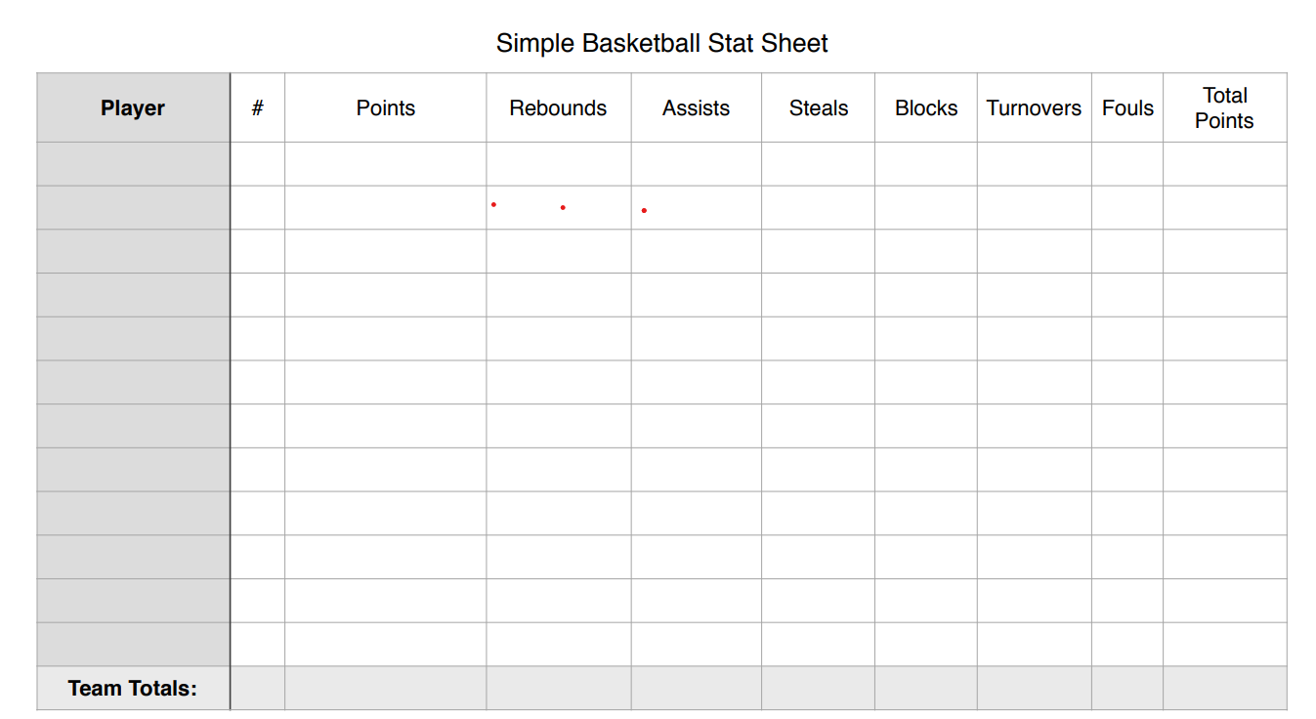

**Do Now: 10/29/24**

1. **Review basketball**

**Classwork:**

1. **Bracket Information & structure**
2. **Coach review tournament expectatins**
3. **Students practice basketball skills with team**

**Do Now: 10/28/24**

1. **Basketball:** [**https://www.youtube.com/watch?v=oyjYgmsM00Q**](https://www.youtube.com/watch?v=oyjYgmsM00Q)

**Classwork:**

1. **Review of rules and fundamentals**
2. **Gym Walk through offense vs. defense**

***Recreational Games ONLY***

***Recreational Games: Expert Panel Assignment***

***Day 1:***

1. ***Choose Group Members (4 per group)***
2. ***Get Game for Research from Coach***
   1. ***Hole in one***
   2. ***Ring toss***
   3. ***Ladder toss (Group E)***
   4. ***Corn hole (Group B)***
   5. ***Ping pong (Group D)***
   6. ***Pickle ball***
   7. ***Spike ball (Group C)***
   8. ***Tennis (Group A)***
3. ***\*\*Based on your game you will delegate portions of Assignment (research based on recreational play)***
   1. ***Intro Page: Name of Game with detail and specific equipment needed, relevant image, list of when you can play this game, where you can play this game, 3 ways those that play this game will benefit from knowing how to play***
   2. ***Rules: Number and list Rules of the game***
   3. ***Skills & Technique: Various skills and techniques and descriptions necessary to play the game (at least 4)***
   4. ***Drills: 3 detailed drills that can help individuals develop the skills to compete in your game***
4. ***In your notebook, write your portion of the assignment and check with Coach Thomas once complete to ensure you have the proper rules and information before putting on large paper.***

***Complete Research (based on recreational play) and write your portion along with your group’s name in notebook-Include your game’s name & your section as the heading***

**Groups Chosen**

|  |  |  |  |  |  |  |
| --- | --- | --- | --- | --- | --- | --- |
| **Group A** | **Group B** | **Group C** | **Group D** | **Group E** | **Group F** | **Group G** |
| **Nevaeh**  **Lia**  **Nylah**  **London** | **Kaden**  **Derrick**  **Aaron**  **Randy** | **Adrianna**  **Heaven**  **Raheem**  **Kingston**  **\*given**  **1.missing equiupment and how you benefit (-10)**  **90** | **Alyssa**  **Kyndall**  **Braxton**  **Jordyn**  **#3 missing heading -5 pts**  **95** | **Arianna**  **Datriuna**  **Khloe** | **Khalia**  **Courtney**  **President-sitting idle 10/29/24**  **Kemmon-sitting idle 10/29/24**  **Hole in one**  **1.unable to read this one -20**  **3. drills are not dtailed-10** | **Catherine**  **Ariana**  **Khloe**  **Datriuan**  **Ladder Toss** |

**Week 10: October 21-25**

**10/25/24**

**Do Now: 10/25/24 N/A**

**Classwork: 10/25/24**

1. **Makeup HR Assessment**
2. **Free Play**

**10/24/24: PSAT**

**Do Now: 10/23/24**

1. **Basketball Statistics Videos**

**Classwork: 10/23/24**

1. **Basketball drills**
2. **Free Play & Practice with Teammates**

**Do Now: 10/22/24**

1. **Watch Basketball Videos to better understand skills**
   1. **Dribbling**
      1. [**https://www.youtube.com/watch?v=HmlJjskzjuo**](https://www.youtube.com/watch?v=HmlJjskzjuo)
      2. [**https://www.youtube.com/watch?v=CMQp0bwjokw&list=PLVvu-7enStA9CdEhaa__s-1ZpV2H_qWht**](https://www.youtube.com/watch?v=CMQp0bwjokw&list=PLVvu-7enStA9CdEhaa__s-1ZpV2H_qWht)
   2. **Passing**
      1. [**https://www.youtube.com/watch?v=oRPlA3Pnkww**](https://www.youtube.com/watch?v=oRPlA3Pnkww)
      2. [**https://www.youtube.com/watch?v=brTSQKqrTVI**](https://www.youtube.com/watch?v=brTSQKqrTVI)
   3. **Defense**
      1. [**https://www.youtube.com/watch?v=hPmc7R_dAxc**](https://www.youtube.com/watch?v=hPmc7R_dAxc)
   4. **Shootin**

**Classwork: 10/22/24**

1. **Basketball Drills in Gym**
   1. **Dribbling**
   2. **Passing**
   3. **Lay ups**
   4. **Free Play**

**Do Now: 10/21/24**

1. Get one group document per group/team and fill in the information based on the people in your group

**Classwork: 10/21/24**

1.Review expectations for the week

2. Warmup & Basketball Drills

**Week 9: October 16-18**

Do Now: 10/18/24 login using information below

1. Using your computer login to **joinmyquiz.com**
   1. Code:
   2. Use first name last initial
2. Place your notebook on my desk
3. Wait for further instructions

Classwork: 10/18/24 Heart Rate Test

Do Now: 10/17/24: Bring Laptops to class tomorrow (everyday)

1. What was your progress report grade in this class?
2. What is your current grade in this class?
3. If you are not passing list two things you can do to make sure you receive credit for the class. If you are passing list two things you can do to make sure you keep passing.

Classwork:

1. Heart Rate Circle Map: review for test

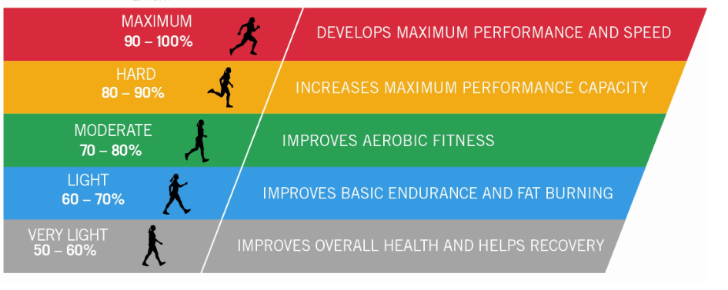

Do Now: 10/16/24: Welcome Back

1. **In the Warmup section of your notebook write a 5-sentence summary of your experience with Hurricane Helene. Include the following**
   1. How were you and your family impacted?
   2. What emotions did you go through?
   3. At least two benefits from this experience

Classwork: 10/16/2024

1. Review of Heart Rate Information
   1. Chart completion
   2. Study guide
2. Wednesday Walk

**Week 8: September 23-27**

**Do Now: 9/26/24**

**Your test is not today so**

1. **When will your test for HR be?**
2. **List two things you should be able to do based on this week’s lesson activities**

**Do Now: 9/25/24**

1. **When is the test for HR?**
2. **Find the radial pulse of your elbow partner and record their name and bpm**
3. **What does bpm stand for?**

**Classwork: 9/25/2024**

**Calculate your Target HR for each zone**

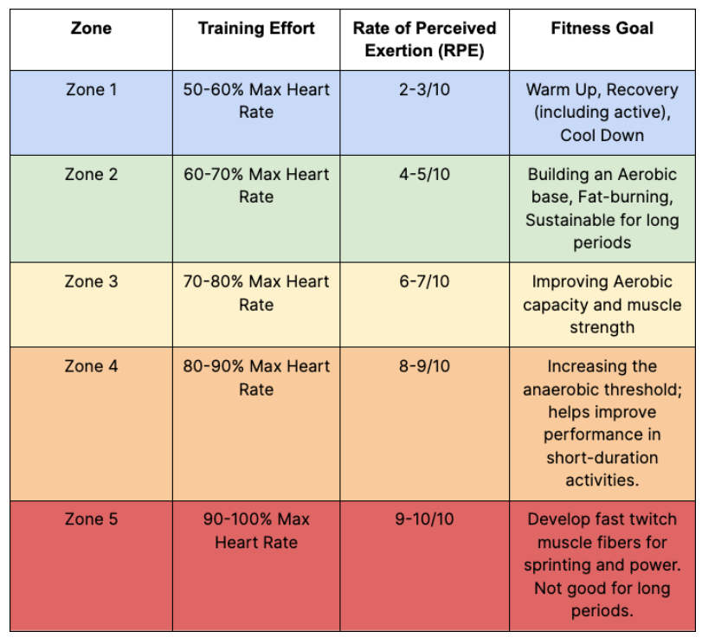

**Zone 1:**

**Zone 2:**

**Zone 3:**

**Zone 4:**

**Zone 5:**

**Do Now: 9/24/24**

1. **What are the two method for checking HR**
2. **Next to each method above list the location it can be found on the body.**
3. **How do you calculate maximum HR?**

**Classwork: 9/24/24**

**Heart Rate Tracking Chart**

**Directions: Fill in the chart by following the headings. Check your Resting as you sit calmly in class, coach will give you the target HR % and you will calculate and put that based on your maximum HR. For each activity coach will give you the activity, you will write it and then check your Heart rate as soon as possible afterwards and record in chart. You should be able to use the data to determine your next steps (if you need to work harder, continue what you are doing or should we adjust your target zone, etc.) when performing physical activity to ensure you are reaching the target HR zone.**

|  |  |  |  |  |
| --- | --- | --- | --- | --- |
| **Date** | **Resting HR** | **Target HR** | **Activity 1 HR** | **Activity 2 HR** |
|  |  |  |  |  |
|  |  |  |  |  |
|  |  |  |  |  |
|  |  |  |  |  |
|  |  |  |  |  |
|  |  |  |  |  |
|  |  |  |  |  |
|  |  |  |  |  |

**Do Now: 9/23/24**

1. **Where is all of the work from this school year?**
2. **What should you do if you are not present at school in order to get your work?**
3. **Where should all of your work be completed unless otherwise stated?**

**Classwork: 9/23/24**

1. **HR video:** [**https://www.youtube.com/watch?v=o7R28_k6i5E**](https://www.youtube.com/watch?v=o7R28_k6i5E)
   1. **Target HR:** [**https://www.youtube.com/watch?v=k60x24nN9CM**](https://www.youtube.com/watch?v=k60x24nN9CM)
   2. **Zone Training: https://www.youtube.com/watch?v=2MvZ_7401aI**
2. **Class Practice** 
   1. **Resting**
   2. **After light cardio**
3. **HR Study Guide**

**Heart Rate Study Guide**

**Key Concepts to Know**

1. **Maximum Heart Rate (Max HR)**
   * Formula: **220 - your age**
   * Example: If you are 16 years old, your Max HR = 220 - 16 = 204 beats per minute (bpm)
2. **Resting Heart Rate (RHR)**
   * This is the number of beats your heart makes per minute while you are at rest. A lower RHR often indicates better cardiovascular fitness.
3. **Target Heart Rate (THR)**
   * Your THR is a range where your heart rate should be during exercise to improve your fitness.
   * **Moderate Intensity**: 50% - 70% of your Max HR
   * **Vigorous Intensity**: 70% - 85% of your Max HR
4. **How to Find Your Pulse**
   * **Radial Pulse**: Located on the inside of your wrist, below the thumb.
   * **Carotid Pulse**: Located on the neck, beside the windpipe.
5. **Checking Your Pulse**
   * Use two fingers (index and middle) to lightly press on the pulse points.
   * Count the beats for 10 seconds and multiply by 6 to get your heart rate (bpm).

**Study Activities**

**Activity 1: Calculate Your Maximum Heart Rate**

* Use the formula **220 - your age** to calculate your Max HR.

1. **My Max HR = ______ bpm**

**Activity 2: Find Your Resting Heart Rate**

* While sitting calmly, find your radial or carotid pulse.
* Count your beats for 10 seconds and multiply by 6.

1. **My Resting Heart Rate = ______ bpm**

**Activity 3: Determine Your Target Heart Rate Zones**

* Calculate 50% and 85% of your Max HR to find your target zones.
* Use these formulas:
  + **50% of Max HR = Max HR x 0.50**
  + **85% of Max HR = Max HR x 0.85**

1. **50% of Max HR = ______ bpm**
2. **85% of Max HR = ______ bpm**

**Activity 4: Practice Finding Your Pulse**

* Practice checking both your **radial** and **carotid** pulse points.

1. Which one is easier for you to find?

**I can find my radial/carotid pulse better.**

**Activity 5: Benefits of Knowing Your Heart Rate**

* Write down two reasons why it’s important to monitor your heart rate during exercise.

1. **Review Questions**
2. What is the formula for Max HR?
3. How do you check your pulse?
4. In at least three complete sentences, explain the purpose of knowing your target HR during physical activity?

**Helpful Tips**

* Practice checking your pulse every day.
* Make sure you can calculate your Max HR and THR quickly.
* Understand why it’s important to stay within your THR zone during exercise.

**Week 7: September 16-20**

**September 20**

**Do Now: 9/20/24**

**Turn in notebook**

**Classwork:**

**Finish vision board presentations**

**Complete volleyball assessment makeups**

**Free Play if time permits**

**September 19**

**Do Now: 9/19**

1. **List the assignments we had this week**
2. **Do the following based on your completion of each assignment**
   1. **Check if completed**
   2. **½ if incomplete**
   3. **X if not done at all**

**Classwork:9/19**

1. **Vision Board Presentations**
   1. **My fitness SMART goal for the semester is**
   2. **Three items on my board that correlate to this goal are**
   3. **How the items correlate**

**September 18**

**Do Now: 9/18/24**

**In the classwork section in your notebook, Create the chart below (after your last assignments completed in this section)**

**\*\*Volleyball Game Stats Assignment :** [**https://www.ncaa.com/game/6191661**](https://www.ncaa.com/game/6191661) **-Pitss vs. Loui**

[**https://www.ncaa.com/game/6327680**](https://www.ncaa.com/game/6327680) **South Carolina vs. East Carolina**

|  |  |  |  |  |  |
| --- | --- | --- | --- | --- | --- |
| **Team Name:** | | | | | |
| **Player #** | **Bumps** | **Sets** | **Serves** | **Serve Faults** | **Comments** |
|  |  |  |  |  |  |
|  |  |  |  |  |  |
|  |  |  |  |  |  |

**Classwork: 9/18/2024**

1. **Complete volleyball assessments**
2. **Volleyball Stats**
   1. **Students last name A-M:**
   2. **Students last name N-Z:**
3. ***Team:*** *Indicate which team the player is on (Team 1 or Team 2).*
4. ***Player:*** *Record the player’s name or jersey number.*
5. ***Bumps (Passes):*** *Record each successful bump.*
6. ***Sets:*** *Record each successful set.*
7. ***Serves:*** *Record each successful serve.*
8. ***Serve Faults:*** *Record if a serve results in a fault (e.g., the ball doesn’t cross the net, or it lands out of bounds).*
9. ***Comments:*** *Use this space to make notes on any outstanding plays or techniques, or to explain trends you notice.*
10. **Free Play if time permits**

**September 17**

**Do Now: 9/17/24**

**Review of assessment expectations & discuss with partner your areas of focus for each hit to ensure your success with the assessment**

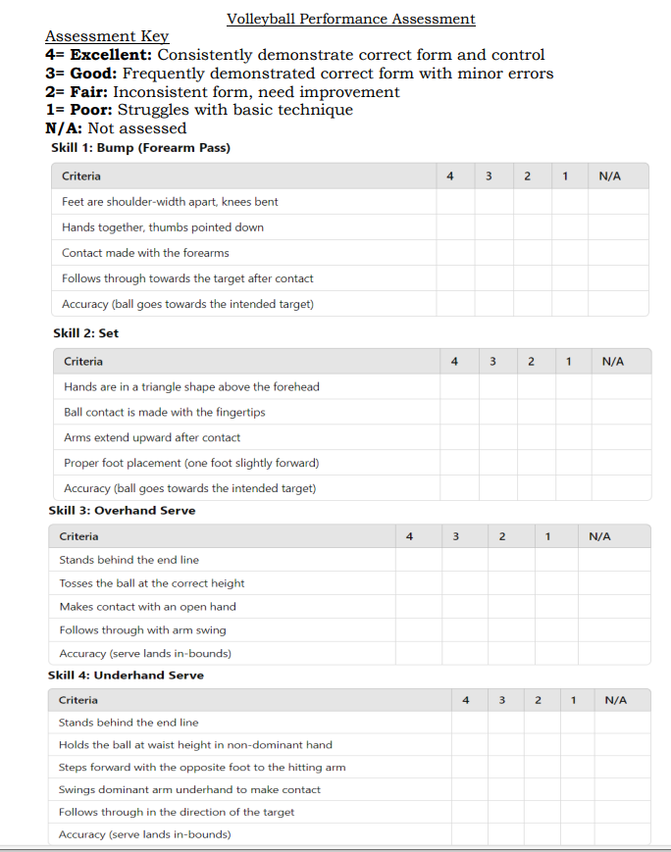

**Classwork:**

**Students will be assessed when called by teacher on the various hits learned for volleyball unit**

**September 16**

**Do Now: 9/16/24**

***In the warmup section of your notebook on a new sheet for the week complete the following***

**USA vs. Germany**

**Make three notes of what you notice about the form and technique of the various hits**

1. **Bump**
   1. **1**
   2. **2**
   3. **3**
2. **Setting**
   1. **1**
   2. **2**
   3. **3**
3. **Serve**
   1. **1**
   2. **2**
   3. **3**

**Classwork:**

**Gym for practice and review of assessment expectations**

**Week 6: September 9-13**

**September 9, 2024**

**Do Now:**

1. **Get your notebook**
2. **On the 2nd page of the warmup section, Write what you see below**

**Do Now: 9/9/24**

**5 Steps for bumping a volleyball**

**1. bend knees (get into starting positions)**

**2. hold hands together with elbows locked out**

**3. footwork/ shuffle to get in front of the ball (chest facing net)**

**4. /angle platform**

**5.Do not swing**

**Classwork:**

1. **Students watch volleyball video and use it to list the steps for bumping a volleyball and fill in warmup assignment**
2. **Youtube.com/watch?v=RANLOfoxjRg** 
   1. **How to bump a volleyball : 3 keys**
3. **Get your vision board and give to Coach Thomas**
4. **Students work on missing assignments**

**September 10**

**Write exactly what you see below on the same sheet as yesterday (2nd page of the warmup sections)**

**Do Now: 9/10/24**

**5 Rules of Volleyball**

**1.**

**2.**

**3.**

**4.**

**5.**

**Classwork:**

1. **2nd & 7th period Volleyball Worksheet Part 1**

**On your own sheet of paper, In the classwork section of your notebook answer the questions by writing the questions and answer of restating the question in the answer for full credit.**

**Part 1: Bumping, Setting, and Serving**

1. **1. Bumping**
2. a. What is the primary purpose of a bump (or forearm pass) in volleyball?
3. b. Describe the correct body position for a bump. Include how your hands should be positioned.
4. c. What are two common mistakes players make when bumping the ball?
5. **2. Setting**
6. a. Explain what the term “setting” means in volleyball.
7. b. What is the primary purpose of a set?
8. c. Describe the correct hand positioning for a set. Why is this positioning important?
9. **3. Serving**
10. a. What are the three main types of serves in volleyball?
11. b. Describe the correct technique for an overhand serve.
12. c. What is one key factor to consider when performing a successful serve?
13. **Volleyball Rules Video & Setting & Serving**

[**https://www.youtube.com/watch?v=0dBMoHaSguw**](https://www.youtube.com/watch?v=0dBMoHaSguw)

[**https://www.youtube.com/watch?v=9g7nYQv-kPM**](https://www.youtube.com/watch?v=9g7nYQv-kPM)

[**https://www.youtube.com/watch?v=hLZ44KBWEbo**](https://www.youtube.com/watch?v=hLZ44KBWEbo)

1. **Louiville vs. Pitt Women’s Volleyball Game**

[**https://www.youtube.com/watch?v=tV6JmCgBVAo**](https://www.youtube.com/watch?v=tV6JmCgBVAo)

1. **Gym for practice (setting & serving) and possible game play**

**September 11**

**Do Now: 9/11/24**

**Write on same sheet in notebook as Monday and Tuesday (2nd page of warmup sections)**

**In at least four complete sentences, explains why this day is significant/important to you as an America or as someone who is currently in America**

**Classwork: 9/11/24**

**1.Students grouped into Team**

**2.Students use skills and strategy to compete and have fun playing volleyball**

**(7th period walk-not following directions)**

**September 12**

**Do Now: 9/12/24 On same sheet as the other warmups from this week**

**1.List the two hits you were taught for volleyball**

**2. List two keys to bumping the ball correctly**

**3. List two keys for setting the ball correctly**

**Classwork: 9/12/24 Same as previous day (7th period Volleyball worksheet instead of game play)**

**September 13**

**Do Now: Work on missing assignment**

**Classwork: Free Play if time permits**

**Week 5: September 2-6**

**September 2nd: Labor Day Holiday**

**September 3rd: Asynchronous Tuesday-Work on Vision Board & SMART goal**

**September 4th Wednesday:**

***Do Now: 9/4/24-***

1. ***Get your notebook, on the 4th page of the Classwork section after your rough draft, write the heading SMART Goal Assignment at the top with your name & the date.***
2. ***Get out your computer & go to my teacher’s page to access the SMART goal reading & assignment***

**Classwork: In the classwork section of your notebook, complete the SMART goal assignment**

**Name: Date: __ Period:__________________**

**Setting S.M.A.R.T. Goals**

**Directions: Read the information/summary below & answer the questions in the classwork section of your notebook. Include the heading and date at the top of your page. Upload a clear image of your answer into Canvas. DUE: September 5th 2024 ; Not accepted after September 13th.**

S.M.A.R.T. goals are specific, measurable, achievable, relevant, and time-bound objectives that help individuals effectively plan and achieve their fitness goals. Setting S.M.A.R.T. goals provides clear direction, increases motivation, and enhances the likelihood of success.

**Description and Example of a S.M.A.R.T. Goal:**

1. **Specific:** The goal should be clear and specific, answering the questions of what, why, and how.
   * Example: "I want to run a 5K race."
2. **Measurable:** The goal should be measurable, allowing progress to be tracked and assessed.
   * Example: "I will track my running distance and time using a running app."
3. **Achievable:** The goal should be realistic and attainable, considering the individual's current fitness level.
   * Example: "I will gradually increase my running distance by 0.5 miles each week."
4. **Relevant:** The goal should be relevant to the individual's overall fitness objectives and aligned with their values.
   * Example: "Running a 5K will improve my cardiovascular health and help me stay active."
5. **Time-Bound:** The goal should have a specific deadline or timeframe.
   * Example: "I will run a 5K race within 3 months."

**Complete S.M.A.R.T. Goal Example:** "I want to run a 5K race (Specific). I will track my running distance and time using a running app (Measurable). I will gradually increase my running distance by 0.5 miles each week (Achievable). Running a 5K will improve my cardiovascular health and help me stay active (Relevant). I will run a 5K race within 3 months (Time-Bound)."

**Questions (There are 10 total questions):**

1. **Multiple Choice:** Which of the following is an example of a specific fitness goal?
   * A. "I want to get fit."
   * B. "I want to run a 5K race."
   * C. "I want to exercise more."
   * D. "I want to be healthier."
2. **Open-Ended:** Why is it important for a fitness goal to be measurable?____________________________________________________________
3. **Multiple Choice:** What does the "A" in S.M.A.R.T. goals stand for?
   * A. Accurate
   * B. Achievable
   * C. Active
   * D. Adjustable
4. **Open-Ended:** Describe a fitness goal that is both relevant and achievable for you.
5. **Multiple Choice:** Which part of the S.M.A.R.T. criteria ensures that a goal has a deadline?
   * A. Specific
   * B. Measurable
   * C. Achievable
   * D. Time-Bound
6. **Open-Ended:** Provide an example of a time-bound fitness goal.
7. **Multiple Choice:** What is the benefit of having a relevant fitness goal?
   * A. It makes the goal easier to achieve
   * B. It ensures the goal aligns with personal values and overall fitness objectives
   * C. It eliminates the need for a deadline
   * D. It makes the goal less specific
8. **Open-Ended:** How can setting a S.M.A.R.T. goal help you stay motivated?
9. **Multiple Choice:** Which of the following is a measurable fitness goal?
   * A. "I want to feel better."
   * B. "I want to run faster."
   * C. "I want to run a 5K race and track my time each week."
   * D. "I want to be more active."
10. **Open-Ended:** Write your own S.M.A.R.T. fitness goal using the criteria described.

**Student S.M.A.R.T. Goal:**

**Specific:______________________________________________________________________**

**Measurable:___________________________________________________________________**

**Achievable:___________________________________________________________________**

**Relevant:_____________________________________________________________________**

**Time-Bound:____________________________**

**September 5th Thursday:**

**Do Now: 9/5/24**

**1.Write your name in one of the designated groups**

**2. Based on the roles provided, write your desired role # for the group next to your name**

**Classwork:**

**1.Students given 5-10 minutes to work on SMART goal assignment as they watch kickball video**

**2. Gym for Kickball**

**September 6th Friday:**

**Do Now: 9/6/24**

**1.Complete SMART goal assignment in notebook (4th page of classwork section)**

**2. Complete Vision Board**

**a. rubric on my teacher page**

**b. paper and other supplies available**

**3. Parents contacted**

**Passing Percentages**

**1st period: 100%**

**2nd period: 7/17- 41%**

**3rd period: 4/9- 44%**

**4th period: 17/32- 53%**

**6th period: 4/15- 27%**

**7th period: 17/39- 44%**

**Week 4: August 26-30**

Warmup: Sign up for groups on board & within each group determine the roles of each person based on those given by coach (will be used the following week)

**August 26**

Do Now:

1. Grab a Fitness Gram Score Sheet from front table
2. Upload Vision Board Rough Draft in Canvas
3. Work on any missing assignments that we have done so far this year (Use my page and Canvas to access the work; NOT ME)
4. This is the last week anything that has been assigned so far will be accepted

Classwork: 8/26/2024

1. Students record height and weight when measured

**August 27**

**Do Now:**

1. Get out your Fitness Gram Score sheet (collect one if you were absent)
2. Prepare mentally for push ups and curl ups
3. Work on any missing assignments that we have done so far this year (Use my page and Canvas to access the work; NOT ME)
4. This is the last week anything that has been assigned so far will be accepted

Classwork: Student complete push up and curl ups in gym with partner & record data

**August 28**

**Do Now:**

1. Get out your Fitness Gram Score sheet (collect one if you were absent)
2. Prepare mentally for Pacer Test
3. Work on any missing assignments that we have done so far this year (Use my page and Canvas to access the work; NOT ME)
4. This is the last week anything that has been assigned so far will be accepted

Classwork: Student complete 15M Pacer Test in gym in gym with partner & record data

**August 29, 2024**

**Do Now: 8/29**

1. **Get out your Fitness Gram Score sheet (collect one if you were absent)**
2. **Make sure your data is complete**
   1. **I will get the height and weight of those that did not get it later**
3. **Work on any missing assignments that we have done so far this year (Use my page and Canvas to access the work; NOT ME)**
4. **Begin Final Draft of Vision Board**
   1. **Construction paper & a few material is at the front table (be sure to put items back when done)**
   2. **If you do not have materials, do the foundational work by writing heading and labels**
   3. **Final Draft is DUE tomorrow 8/30/24**

**Classwork: Student complete makeups for fitness gram**

**August 30, 2024**

1. **Get your Vision Board out of your notebook (if it is in there)**
2. **Turn your notebook on Coach Thomas’ desk**
   1. ***(should be setup properly, rough draft of vision board should be in classwork section, Physical Activity Log in the back, Fitness gram score sheet in the back)***
3. **Work on any missing assignments that we have done so far this year (Use my page and Canvas to access the work; NOT ME)**
4. **Complete Final Draft of Vision Board**
   1. **Final Draft is DUE TODAY**

**FitnessGram Score Sheet**

Name: __________________________________________________________

DOB (MM/DD/YYYY): _______________ Age: _________ Gender (M/F):_____

Teacher: ________________________ Period: ________________________

As we complete FitnessGram Testing, it is your responsibility to record your own personal data. On the last day of the unit, you will turn this sheet in to your teacher for input into the FitnessGram data base. *If you lose your sheet, you will have to redo all missing assessments! Please keep up with your work.*

*Assessment Schedule:*

* HT/ WT/Sit & Reach: Aug. 26th
* Push-ups & Curl-Ups: Aug. 27th
* Pacer: Aug. 28th
* Make ups: Aug. 29th
* Fitness Components Assessment**: Aug. 30th

|  |  |
| --- | --- |
| **Assessment Item** | **Student Performance** |
| Height (Body Composition) | Ft.: In.: |
| Weight (Body Composition) | Lbs.: |
| Sit & Reach (Flexibility) | In.: |
| Curl Ups (Muscular Strength & Endurance) |  |
| Push Ups (Muscular Strength & Endurance) |  |
| Pacer (Aerobic Capacity) |  |

**Name: Date:**

**Period:**

**Understanding the Importance of the FitnessGram**

**Summary:**

The FitnessGram is a comprehensive fitness assessment tool used in schools to evaluate the physical fitness levels of students. It provides valuable insights into students' fitness, helping to identify strengths and areas for improvement. The FitnessGram is important for high school students as it promotes lifelong physical activity, helps set personal fitness goals, and encourages healthy lifestyle choices.

**Importance of the FitnessGram:**

1. **Holistic Fitness Assessment:** The FitnessGram assesses various components of physical fitness, including cardiovascular endurance, muscular strength, muscular endurance, flexibility, and body composition. This comprehensive evaluation helps students understand their overall fitness levels.
2. **Personalized Feedback:** Students receive individualized feedback on their performance, highlighting their fitness strengths and areas that need improvement. This personalized approach motivates students to work on specific fitness goals.
3. **Promotion of Lifelong Fitness:** By participating in the FitnessGram, students learn the importance of maintaining physical fitness throughout their lives. It encourages the development of healthy habits that can lead to long-term wellness.
4. **Goal Setting:** The FitnessGram helps students set realistic and achievable fitness goals. By understanding their current fitness levels, students can create personalized fitness plans to improve their health and performance.
5. **Encouragement of Physical Activity:** Regular physical activity is crucial for maintaining overall health. The FitnessGram encourages students to engage in physical activities both inside and outside of school, fostering a culture of active living.
6. **Identification of Health Risks:** The FitnessGram can identify potential health risks related to physical inactivity and poor fitness levels. Early identification allows for timely interventions to improve health outcomes.
7. **Educational Tool:** The FitnessGram is an educational tool that teaches students about the different components of fitness and how to achieve and maintain them. It provides practical knowledge that students can apply in their daily lives.
8. **Data-Driven Decisions:** Schools can use FitnessGram data to make informed decisions about their physical education programs. By analyzing trends and identifying areas of need, schools can develop targeted interventions to improve student fitness.

**Questions:**

1. **Multiple Choice:** What are the components of fitness assessed by the FitnessGram?
   * A. Speed, agility, balance
   * B. Cardiovascular endurance, muscular strength, muscular endurance, flexibility, body composition
   * C. Coordination, reaction time, power
   * D. All of the above
2. **Open-Ended:** Why is it important for students to receive personalized feedback from the FitnessGram?
3. **Multiple Choice:** How does the FitnessGram promote lifelong fitness?
   * A. By providing short-term fitness goals
   * B. By encouraging the development of healthy habits
   * C. By focusing solely on athletic performance
   * D. By assessing only one component of fitness
4. **Open-Ended:** Describe how the FitnessGram can help students set realistic fitness goals.
5. **Multiple Choice:** Which of the following is a benefit of identifying health risks through the FitnessGram?
   * A. Ignoring the risks
   * B. Early identification allows for timely interventions
   * C. It discourages students from exercising
   * D. It promotes unhealthy competition
6. **Open-Ended:** Explain how the FitnessGram can be used as an educational tool in physical education.
7. **Multiple Choice:** Why is regular physical activity encouraged by the FitnessGram?
   * A. To promote overall health
   * B. To increase competition among students
   * C. To focus on athletic performance only
   * D. To reduce school workload
8. **Open-Ended:** How can schools use FitnessGram data to improve their physical education programs?
9. **Multiple Choice:** What does the FitnessGram help students understand about their fitness levels?
   * A. Only their strengths
   * B. Only their weaknesses
   * C. Both their strengths and areas for improvement
   * D. None of the above
10. **Open-Ended:** Reflect on your personal experience with the FitnessGram. How has it influenced your approach to physical fitness?

**Week 3: August 19-23**

**August 19**

**Do Now:**

1. **Write name on front and back inside cover**
2. **Write class period next to your name**
3. **Least 1st three pages blank**
4. **Fold the 4th page and label as warmup**
5. **Count 15 blank pages**
6. **Fold the page after the 15th page and label as Classwork**

*Warmup: Using paper provided: Fold paper hamburger style. Leave the paper folded and fold hamburger style again. Open your paper up and you should have 4 sections just as you see below. Draw a box in the center to write the title of your organizer, your name, and your class period. Write the principles at the top of each section as you see below & wait for further instructions.*

Create organizer below for Principles of Fitness: FITT, specificity, progression, overload

|  |  |
| --- | --- |
| **FITT**  F-  I-  T-  T-  Description:  Example 1:  Example 2:  Risk:  4 Principles of Fitness  Name & Period | **Specificity**  Description:  Example 1:  Example 2:  Risk: |
| **Progression**  Description:  Example 1:  Example 2:  Risk: | **Overload**  Description:  Example 1:  Example 2:  Risk: |

1. Brief description (for FITT include a description of what each letter represents and means)
2. 1 research example
3. 1 example of how you can apply the principle to your life
4. Risk if principle is ignored (be specific to the principle)

Distribute Fitness Log explained

Classwork: Coach explain fitness log & role out vision board project, give handouts, students complete research & rough draft

-Fitness Circuit in Class

-Spike ball video for Rec Games & Lifetime Sports (6th & 7th):

1. <https://www.youtube.com/watch?v=irgTrG6d6eA>

**August 20**

Warmup- You have 15 minutes to work on your 4 Principles Organizer

Classwork-Gym (warmup & free play)

**August 21**

Warmup: Reminded of project / students given chance to ask questions & 10 minutes to work on finishing touches of organizer & upload in Canvas

Classwork: Fitness Day(walk & free play)

**August 22**

Do Now: Using the third page in the classwork section of your notebook,

1. Go to my page to get the vision board rubric
   1. Work with a partner if you do not have a computer
2. Write heading at the top: Vision Board Rough Draft
3. Go one step at a time to complete the rough draft, using labels/headings
   1. For images you will print or cut out, sketch it out or write a note in its place

Classwork: Warmup & Free play in Gym

**August 23**

Classwork: Using the same steps as the previous day complete rough draft of Vision Board

Student conferences

Work on Project

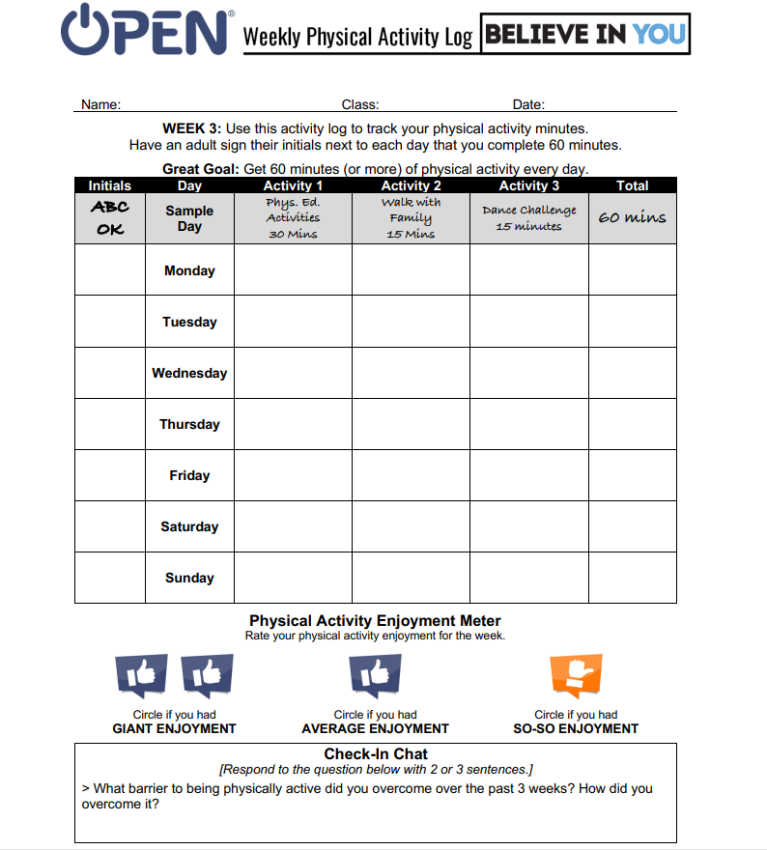

**Name________________________________________________Period___________**

**I BELIEVE IN ME: Vision Board**

|  |  |  |  |
| --- | --- | --- | --- |
| **Requirements: Create YOUR vision board using the rubric below along with the examples provided by coaches. Use the dates to complete your research and ensure that you are on track to have your assignment turned in on time.** | **Possible Points** | **Points Earned** | **Self-Check** |
| 1. Name, Class Period, Headings, Color & Organization | 20  (Aug 22) |  |  |
| 1. How to stay safe while physically active | 5  (Aug 22) |  |  |
| 1. Why living a physical lifestyle is important for our physical and mental health | 10  (Aug 22) |  |  |
| 1. TWO activities you would like to learn more about this year in physical education | 5  (Aug 22) |  |  |
| 1. One thing that makes it difficult for you be physically active | 5  (Aug 22) |  |  |
| 1. Three printed/cut out pictures from magazine, books, etc. **only those that receive written approval from coach by 8/23/24 can receive credit for pictures drawn** | 10  (all or none)  (Aug 26) |  |  |
| 1. Two solutions for overcoming challenges for | 10  (Aug 23) |  |  |
| 1. How can you make physical activity enjoyable for you? | 5  (Aug 23) |  |  |
| 1. Terms: self-management, self-awareness, personal space, encourage, enjoy, enthusiasm, health, health-related fitness, respect, wellness, | 10  (Aug 23) |  |  |
| 1. How will you apply the principle of fitness to your physically active lifestyle *(be able to thoroughly and specifically explain each of these and more importantly, make sure they apply specifically to your uniqueness)*   A. FITT C. overload  B. specificity D. progression | 20  (Aug 26) |  |  |
| You should at least begin the construction of your final project by August 26, 2024  ***FINAL PROJECT DUE: FRIDAY 8/30/24***  Total | 100 |  |  |

**Week 2: August 12th -16th**

**Monday: August 12**

Do Now/Warmup using paper provided by Coach:

1. List three things you think of when you hear the word CPR.
2. Who should administer CPR if you are hanging out and someone is no longer breathing.

Classwork: Ready for CPR Questions: prior to video

1. Can I get in legal trouble for imperfect CPR?
2. If a person is injured, but has stopped breathing, can I make the situation worse by doing CPR?
3. Explain/justify your answer to number 2.

Checking for understanding questions CPR video

**Videos:** [**https://ebooks.heart.org/epubreader/cpr-first-aid-anywhere-streaming-video**](https://ebooks.heart.org/epubreader/cpr-first-aid-anywhere-streaming-video)

**After video students will be called in groups of 4 per class to practice **

*Directions: Watch Video & answer question: Write the question & answer or put your answer in a complete sentence that restates the question within the answer*

1. What happens to a person during cardiac arrest?
2. What happens during a heart attack?
3. What is the first step when you arrive to a scene and a person has collapsed?
4. When you do hands on CPR, how many chest compressions should you do per minute?
5. How deep should you push on the chest of a teen or adult when doing hands only CPR?
6. List the steps for providing hands only CPR?
7. What is the function of an AED?

**Tuesday: August 13**

**Do Now: Warmup:**

1. **List two reasons someone might need CPR.**
2. **If the scene where someone is no longer breathing is not safe, what should you do?**

**\*Video then practice & answer questions\***

**AED Review Questions (write the Q & A for full credit)**

1. How does the AED assist with cardiac arrest?
2. True or False: The AED reads and analyzes the heart rhythm determines whether a shock is needed.
3. Where are most AED mounted?
4. What is the first thing you do when using an AED?
5. Prior to delivering the shock from the AED, what should one do?
6. True or False: You should stop compressions when setting up and using an AED?
7. If there are no child options for the AED such as pads or a switch, what should you do?

**Wednesday: August 14**

**As always, write the questions & answer for full credit\***

**Adult CPR with Breaths Questions**

1. Why are using the breaths an important part of CPR?
2. Fill in the blanks. You should give ___________ breaths for every ________ compressions.
3. List two thing that tilting the head and lifting the chin does for a person that is not breathing?
4. List 5 steps for giving breaths during CPR.
5. What should you watch for as you are giving breaths to a person during CPR?

**Child CPR**

1. What is usually the cause of cardiac arrest in children?
2. Give two examples of the cause you listed for number 1.
3. Based on the reason given for number 1, it is important to give what during child CPR?
4. At what depth should you go for child CPR compressions?
5. How many compressions should you give per minute for child CPR?
6. What should you do if you are alone and no one has called 911, but the child needs CPR?
7. What is the key difference between adult CPR and child CPR?
8. What is the benefit of early CPR in a child?

**Thursday: August 15**

**\*Do Now:** quizziz (use the code based on your Coach)

**Classwork**

*Students allowed to use this day as a makeup

*Those that did not complete the practice will do so when called

**Friday: August 16**

* CPR assessment
* Gym Free day if time permits

**Week 1: August 6th -9th**

**Friday August 9:** complete muscles assignment and upload into Canvas

**Thursday August 8:** Complete muscles handout on own paper while watching videos & review as a class afterwards (students reminded to write in or correct answers)





1. **The rectus abdominis is best known for which function?**
   * A) Knee extension
   * B) Spine flexion
   * C) Elbow extension
   * D) Arm abduction
2. **Which muscle group is targeted during squats?**
   1. A) Biceps
   2. B) Quadriceps
   3. C) Pectorals
   4. D) Deltoids
3. **The primary action of the erector spinae muscles is to:**
   1. A) Flex the spine
   2. B) Extend the spine
   3. C) Rotate the trunk
   4. D) Abduct the arm
4. **Which muscle is located on the shoulder?**
   1. A) Triceps
   2. B) Deltoid
   3. C) Gastrocnemius
   4. D) Soleus
5. **The primary function of the hamstrings is to:**
   1. A) Extend the knee
   2. B) Flex the knee
   3. C) Flex the elbow
   4. D) Extend the elbow
6. **Which muscle group is primarily worked during a deadlift?** A) pectorals B)abdominals

C) gluteals D) Biceps

**Videos**: 1. <https://www.youtube.com/watch?v=58gI3jXNnPI> Major Muscle Groups of the Human Body oR <https://www.youtube.com/watch?v=z7psWfRLXFY> 2. <https://www.youtube.com/watch?v=rMcg9YzNSEs> The Muscular System explained in 6 minutes

**Wednesday August 7:** Students watch muscles video & then go to the gym to review expectations and complete static & dynamic warmup & walk

**\*\*\*First Day: Tuesday August 6:** review of expectations & gym expectation review & walk

1. Muscle Video: <https://m.youtube.com/watch?V=z7psWfRLXFY>
   1. **Muscles to identify**

(Groups of 2-3-each person in the group should share the assignment equally)

* + 1. Pectoralis major
    2. Bicep
    3. Trapezius
    4. Deltoid
    5. Obliques
    6. Quadriceps
    7. Hamstrings
    8. Gastrocnemius
    9. Gluteus Medius
    10. Latissimus dorsi
  1. Use the paper/index card provided and write the name of the muscle on the side without line
  2. ON the side with lines write the word function and the muscle’s function next to it
  3. On the side with lines write the word exercise and an exercise to strengthen that muscle (be able to perform/demonstrate the exercise)

1. Introductions/Descriptions Shirt Painting Tag

**Physical Education Questionnaire**

Canvas Discussion Board 1:

1. What do you know about health-related fitness?
2. How is a physically active lifestyle related to health-related fitness?
3. Why is it important to understand and be aware of our health-related fitness?
4. What do you know about each of the components of health-related fitness?